MACH4METAL

metalworking machinery
Transito 21, 6909 DA Babberich, Netherlands
Tel. + 31 (0)316 – 247123
Fax. + 31 (0)316 - 247956
info@mach4metal.com
www.mach4metal.com
Bank No : 66.52.13.883
IBAN : NL33 INGB 0665 2138 83
BIC : INGBNL2A
VAT : NL 815393635B01

ZAYER ZF 2000 Bed milling machine

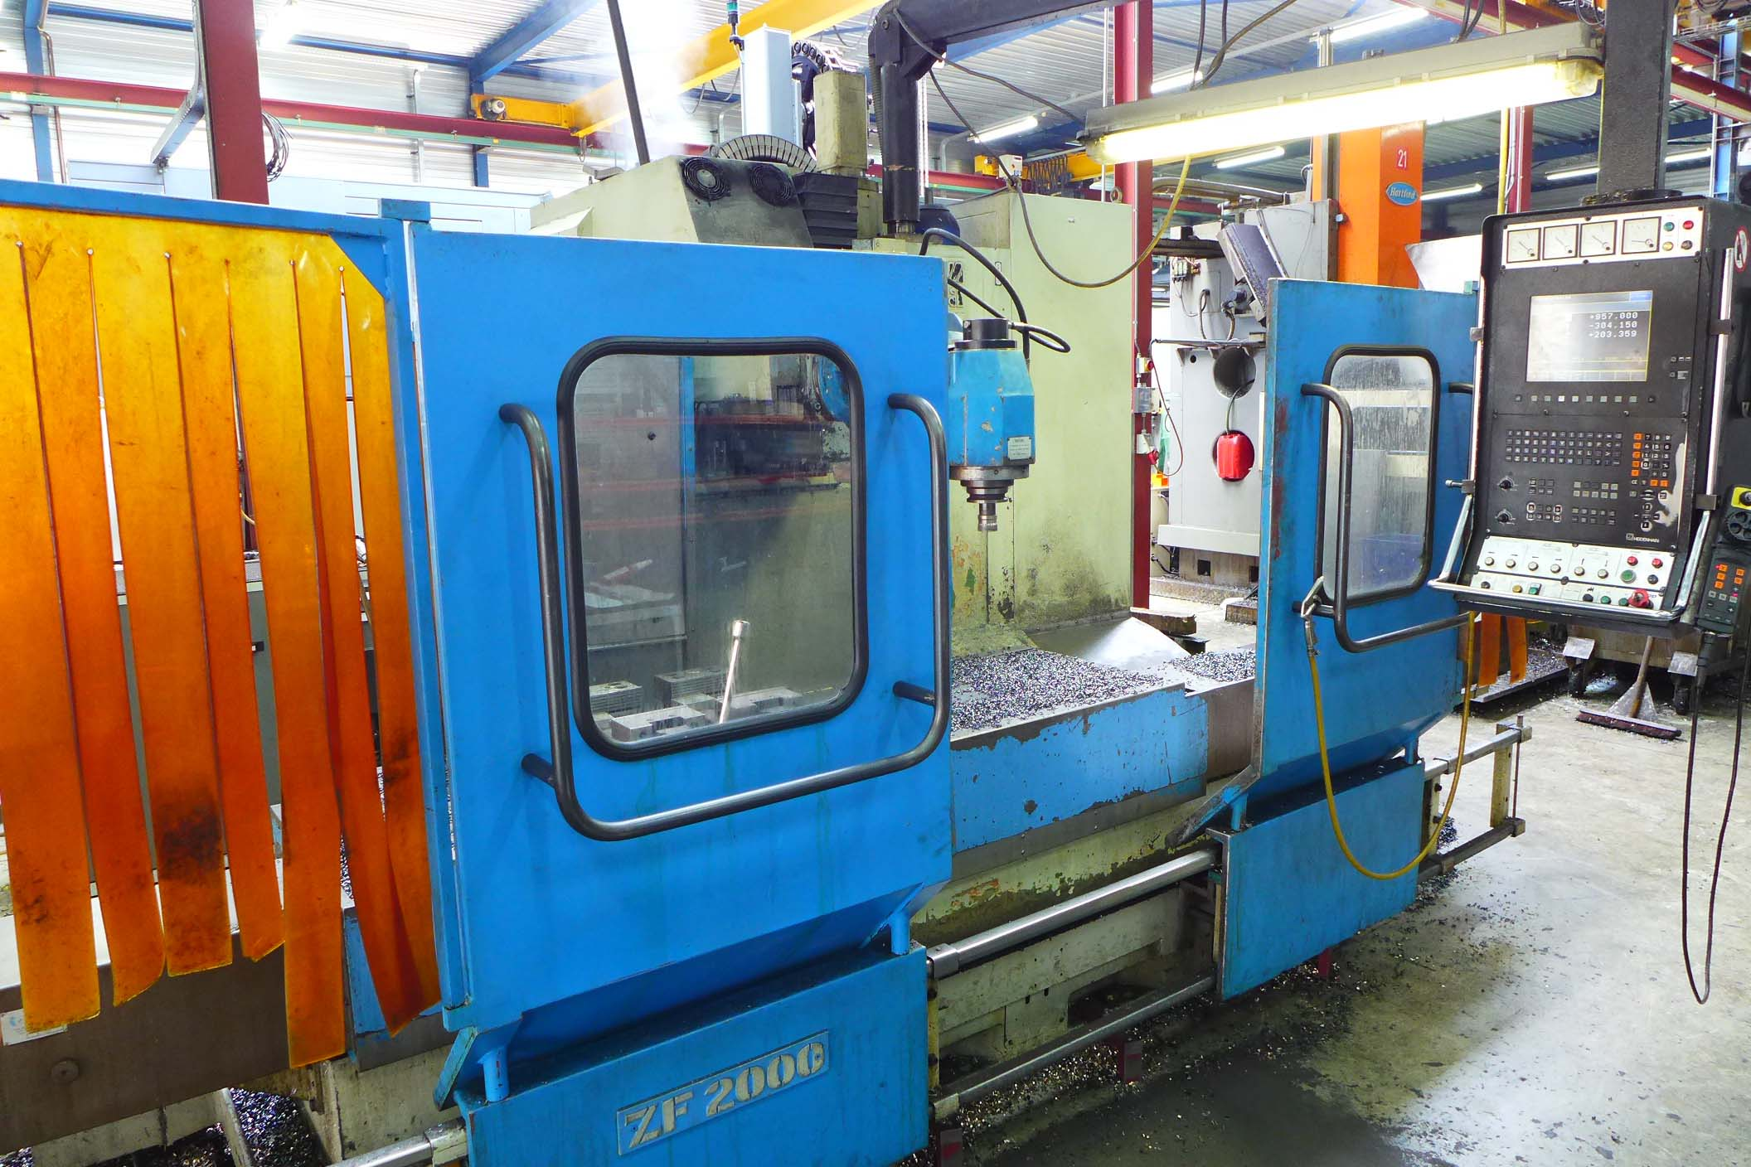

- Make : Zayer - Spain
- Type : ZF 2000
- Age : 1996
- Serial No : 24002

- Table length :2.000
- Table width : 630
- Table load :6.000
- Table – spindle : 780
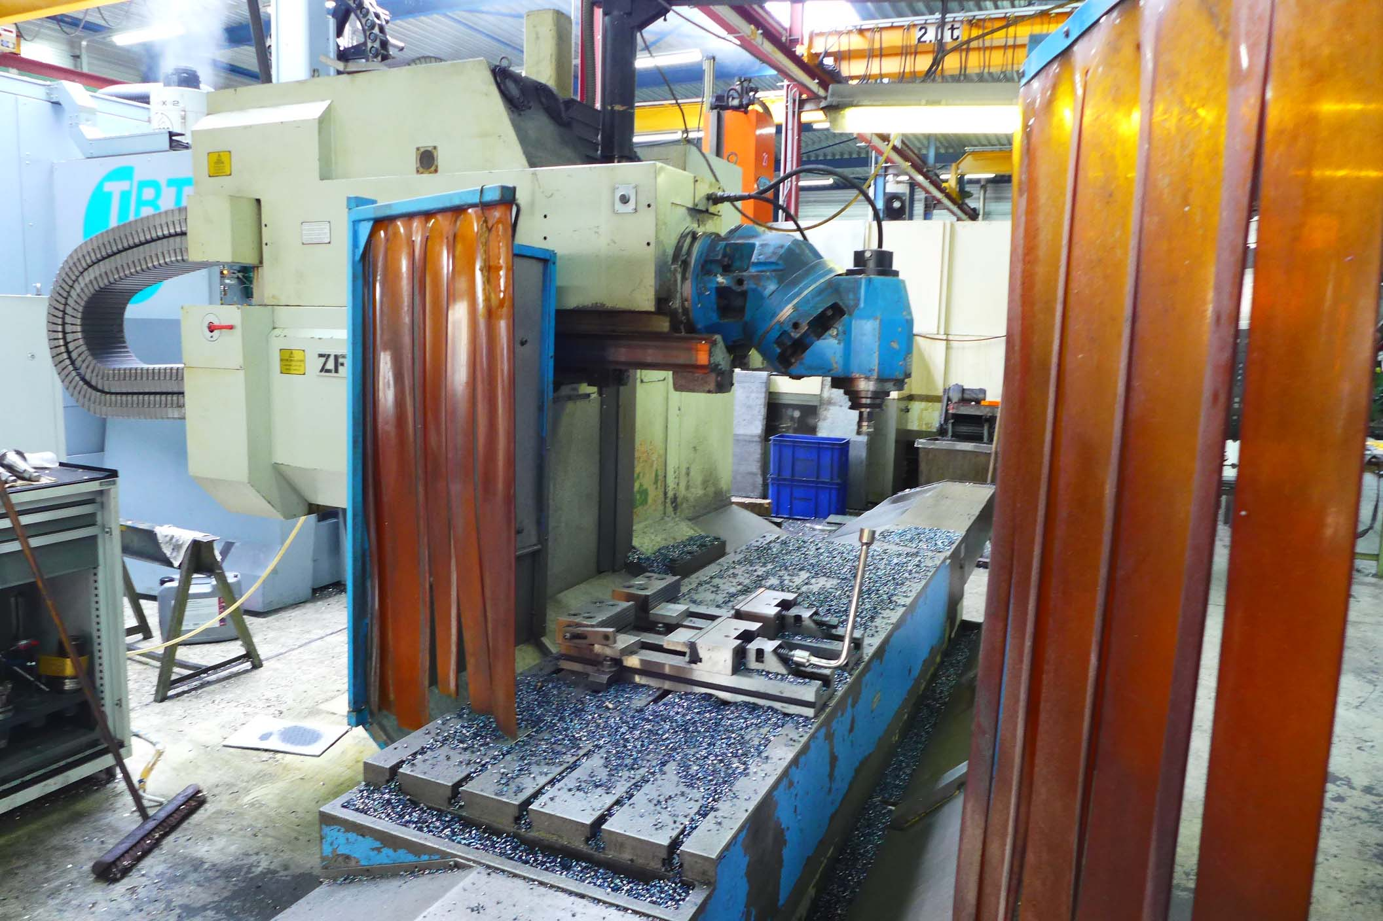

- Working Capacity
- X Travel : 1.700
- Y Travel : 800
- Z Travel : 800

- Speeds : 35 – 3.000
- Feeds : 0 – 15.000
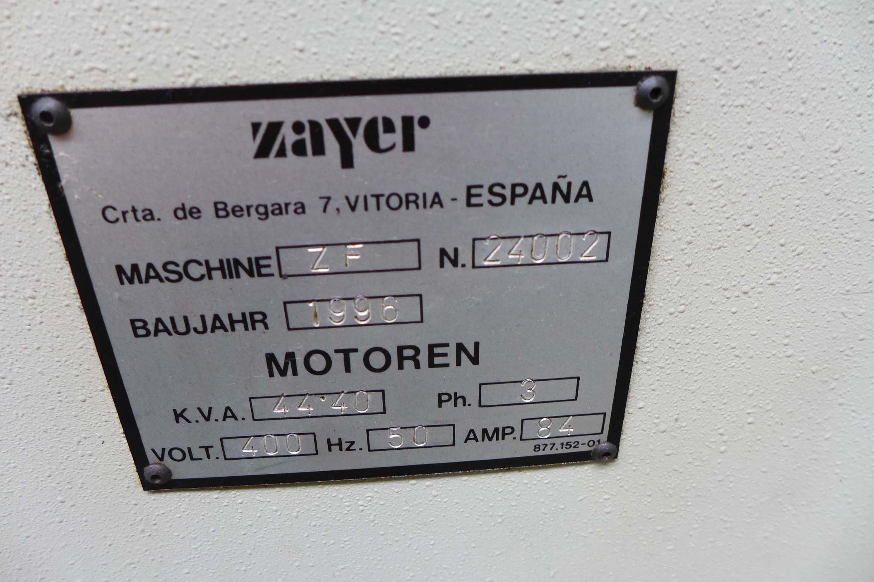
- Spindle taper : ISO 50
- Power : 22 Kw

- Universal milling head
- CNC Heidenhain TNC 426
- HeidenHain HR 410 handwheel
- Central lubrication
- 2 Doors

Please Note: The above information has been obtained to the best of our ability and belief from, and from the manufacturers where possible. It is given in good faith, but its accuracy can not be guaranteed. Accordingly, it will not form a representation or constitute contractual terms. We advise you to check any vital details!

